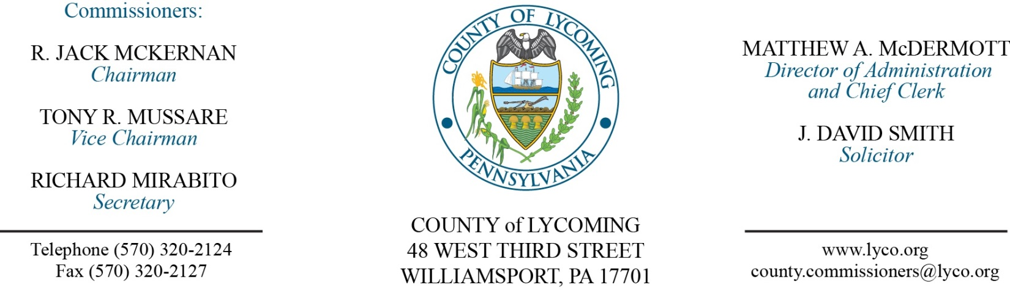
Commissioners’ Meeting Agenda
September 22, 2016

Opening Prayer

Pledge to the Flag

1.0 OPERATIONS

1.1 Convene Commissioners’ meeting.

1.2 Approve the minutes of the previous meetings.

1.3 Receive public comments (agenda items only).

Recess Commissioners’ Meeting

Public Hearing
Lycoming County obo South Williamsport Borough
FFY 2015 CDBG Budget Modification
(Kristin McLaughlin)

Recess Commissioners’ Meeting

2.0 ACTION ITEMS

2.1 Approve submission of budget modification on behalf of South Williamsport Borough. (Kristin McLaughlin)

2.2 Approve Lycoming County FFY 2013 CDBG budget revision. (Kristin McLaughlin)

2.3 Approve Lycoming County FFY 2016 CDBG project finalization. (Kristin McLaughlin)

2.4 Adopt resolution 2016-20 for implementing a strike contingency plan.

2.5 Approve Medical Assistance Transportation Program Grant in the amount of $1,851,045. (Rachelle Abbott)

2.6 Approve subrecipient monitoring contract with STEP for the Medical Assistance Transportation Program in the amount of $1,851,045. (Rachelle Abbott)

2.7 Approve professional service agreement with Sunbury Motors for Resource Management Services. (Mya Toon)

2.8 (remove from table) Approve agreement with youth services agency for JPO. (Mya Toon)

2.9 Award contract to Spector Manufacturing, Inc., for 2-New 2016 75-Cubic Yard Transfer Trailers in the total amount of $103,276. (Mya Toon)

2.10 Approve professional service agreement with Trisha Hoover Jasper for conflicts attorney services not to exceed $17,501.00/annually. (Adrianne Stahl)

2.11 Approve agreement with NorthPointe for annual license renewal in the amount of $15,884. (Karl Demi)

2.12 Approve TDA changes: Maintenance – remove one custodial worker I, grade 1 position; add one custodial supervisor, grade 6/7. PCD – change transportation planner grade 10/11 to transportation supervisor, grade 10/11; add one transportation planner, grade 8/9. (Roxanne Grieco)

2.13 Approve the following personnel actions: (Roxanne Grieco)
Maintenance – promotion of Kendra J. Gates as full time Custodial Supervisor – Pay grade 6 - $16.42/hour effective 9/25/16.
PCD – reclassification of Mark R. Murawski as full time Transportation Supervisor – Pay grade 11 - $70,430.60/annually effective 9/25/16.
PCD – Scott R. Williams as full time Transportation Planner – Pay grade 8 - $39,160.80/annually effective 9/25/16.
Courts – James J. Carey as part time replacement Bailiff – Pay grade 2 - $10.83/hour effective 9/26/16, not to exceed 1,000 hours annually.
RMS – promotion of Barry J. Steinbacher as full time replacement Resource Recovery Assistant Manager – Pay grade 9 - $25.26/hour effective 9/25/16.
DA – Melissa Bell to full time Clerk III – Pay grade 4 - $13.81/hour effective 12/4/16.
DA – Scott J. Werner, Jr. as full time replacement Assistant District Attorney – Union - $52,250.56/annually effective 10/3/16.

Recess Commissioners’ Meeting

3.0 SALARY BOARD

3.1 Convene Salary Board.

3.2 Approve update to the salary schedule:
Maintenance – remove one custodial worker I, grade 1 position; add one custodial supervisor, grade 6/7. PCD – change transportation planner grade 10/11 to transportation supervisor, grade 10/11; add one transportation planner, grade 8/9.

3.3 Adjourn Salary Board.

Reconvene Commissioners’ Meeting

5.0 REPORTS/INFORMATION ITEMS

5.1 Request bids for bunker renovation @ White Deer Golf Course. (Mya Toon)

6.0 COMMISSIONER COMMENT:

7.0 PUBLIC COMMENT:

8.0 NEXT REGULARLY SCHEDULED MEETING: Planning Session on Tuesday, September 27, 2016.

9.0 ADJOURN COMMISSIONERS’ MEETING.

